Personal SWOT Analysis Instructions
To perform a personal SWOT analysis, consider the following questions and complete the worksheet on page 3.
A completed example is also included for your information.

Strengths  - What advantages do you have that others don't have (for example, skills, certifications, education, or connections)?  - What do you do better than anyone else?  - What personal resources can you access?  - What do other people (and your boss, in particular) see as your strengths?  - Which of your achievements are you most proud of?  - What values do you believe in that others fail to exhibit?  - What is the strength of your network? What connections do you have with influential people?  Tip:  Think about your strengths in relation to the people around you. For example, if you're a great mathematician and the people around you are also great at math, then this is not likely to be a strength in your current role – it may be a necessity. | Weaknesses  - What tasks do you usually avoid because you don't feel confident doing them?  - What will the people around you see as your weaknesses?  - What are the gaps in your education and skills training?  - What are your negative work habits (for example, are you often late, are you disorganized, do you have a short temper, or are you poor at handling stress)?  - Do you have personality traits that hold you back in your field? For instance, if you have to conduct meetings on a regular basis, a fear of public speaking would be a major weakness.  Tip:  Consider this from a personal/internal perspective and an external perspective. Do other people see weaknesses that you don't see? Do co-workers consistently outperform you in key areas? Be realistic – it's best to face any unpleasant truths as soon as possible.
Opportunities  - What new technology can help you? Or can you get help from others or from people via the internet?  - Is your industry growing? If so, how can you take advantage of the current market?  - Do you have a network of strategic contacts to help you, or offer good advice?  - What trends (management or otherwise) do you see in your company, and how can you take advantage of them?  - Are any of your competitors failing to do something important that you are really good at? If so, can you take advantage of this situation?  - Is there a need in your company or industry that no one is filling?  - Do your customers or vendors complain about something in your company? If so, could you create an opportunity by offering a solution?  Tip:  Look at your strengths and ask yourself whether these open up any opportunities – and look at your weaknesses and ask yourself whether you could open up opportunities by eliminating those weaknesses. | Threats  - What obstacles do you currently face at work?  - Are any of your colleagues competing with you for projects or roles?  - Is your job (or the demand for the things you do) changing?  - Does changing technology threaten your position?  - Could any of your weaknesses lead to threats?  - Is your organization or industry moving to an environment that is unfamiliar to you or doesn’t utilize your strengths?  - Are your peers outdistancing you in key areas?

A Personal SWOT Example
Strengths  What do you do well?  What unique resources can you draw on?  What do others see as your strengths? | Weaknesses  What could you improve?  Where do you have fewer resources than others? What are others likely to see as weaknesses?
- I'm very creative. I often impress clients with a new perspective on their brands.  - I communicate well with my clients and team.  - I have the ability to ask key questions to find just the right marketing angle.  - I'm completely committed to the success of a client's brand. | - I have a strong, compulsive need to do things quickly and remove them from my "to do" list, and sometimes the quality of my work suffers as a result.  - This same need to get things done also causes me stress when I have too many tasks.  - I get nervous when presenting ideas to clients, and this fear of public speaking often takes the passion out of my presentations.
Opportunities  What opportunities are open to you?  What trends could you take advantage of?  How can you turn your strengths into opportunities? | Threats  What threats could harm you?  What is your competition doing?  What threats do your weaknesses expose you to?
- One of our major competitors has developed a reputation for treating their smaller clients poorly.  - I'm attending a major marketing conference next month. This will allow for strategic networking and offer some great training seminars.  - Our art director will go on maternity leave soon. Covering her duties while she's away would be a great career development opportunity for me. | - Simon, one of my colleagues, is a much stronger speaker than I am, and he's competing with me for the art director position.  - Due to recent staff shortages, I'm often overworked, and this negatively impacts my creativity.  - The current economic climate has resulted in slow growth for the marketing industry. Many firms have laid off staff members, and our company is considering further cutbacks.

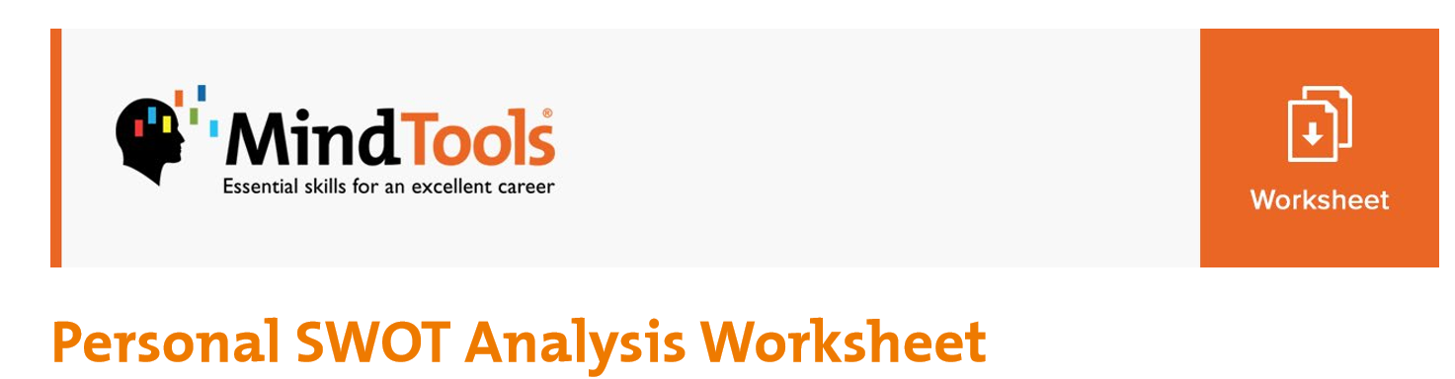
Strengths  What do you do well?  What unique resources can you draw on?  What do others see as your strengths? | Weaknesses  What could you improve?  Where do you have fewer resources than others? What are others likely to see as weaknesses?
Opportunities  What opportunities are open to you?  What trends could you take advantage of?  How can you turn your strengths into opportunities? | Threats  What threats could harm you?  What is your competition doing?  What threats do your weaknesses expose you to?
© Copyright Mind Tools Ltd, 2006-2017.

